# Same digit Interpolates

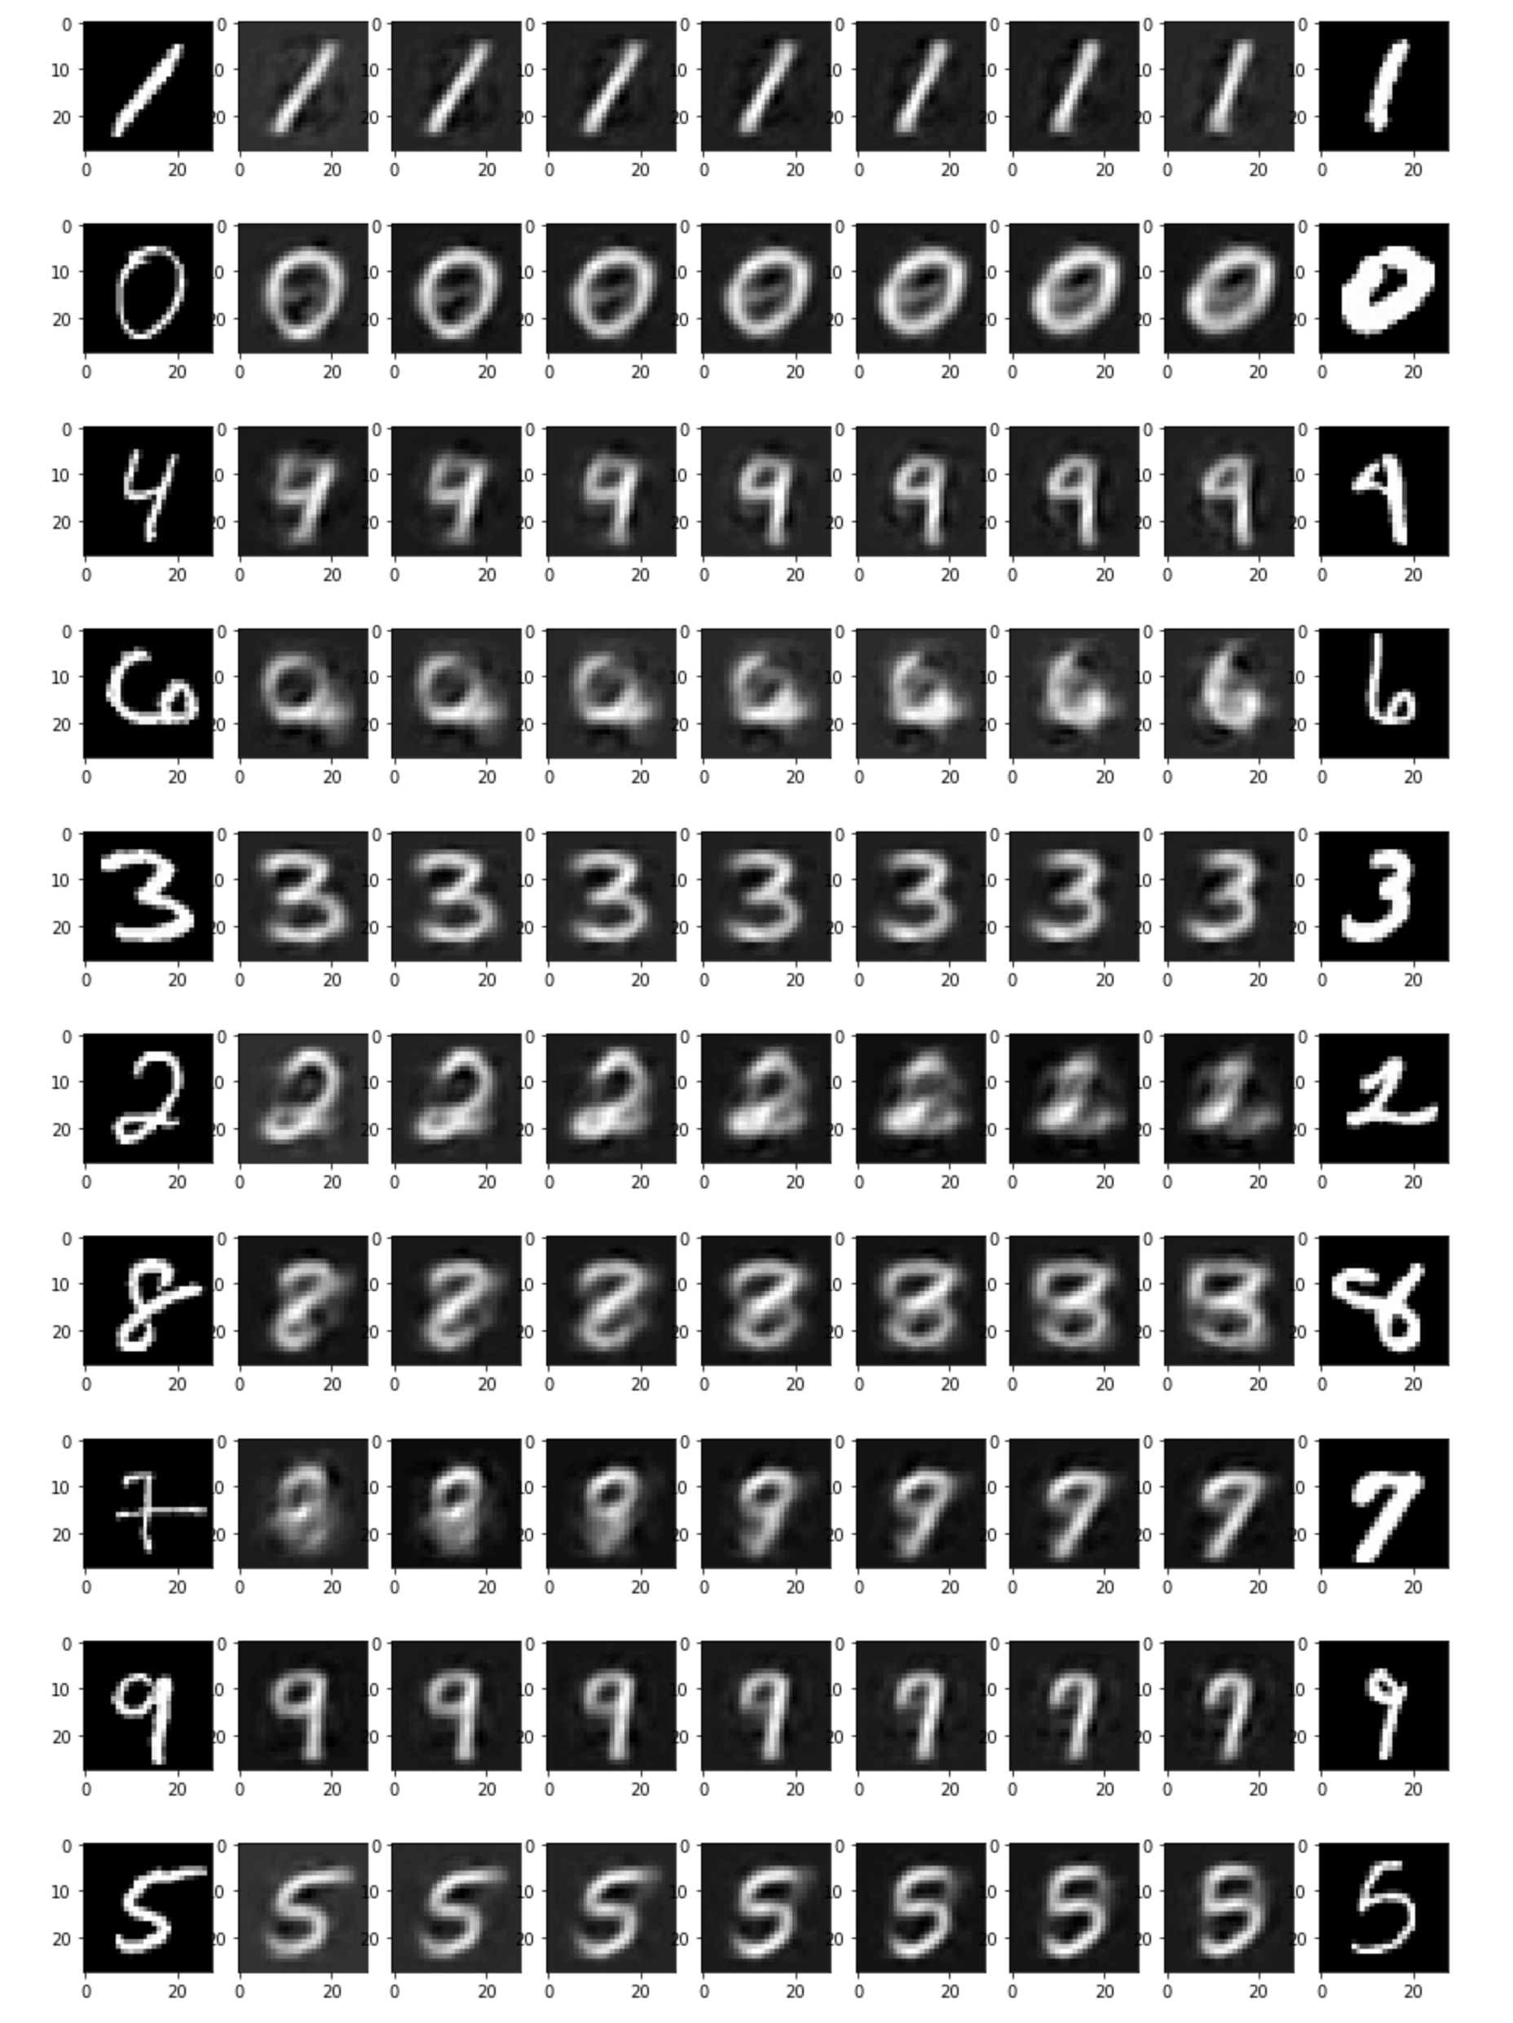

# Different digit Interpolates

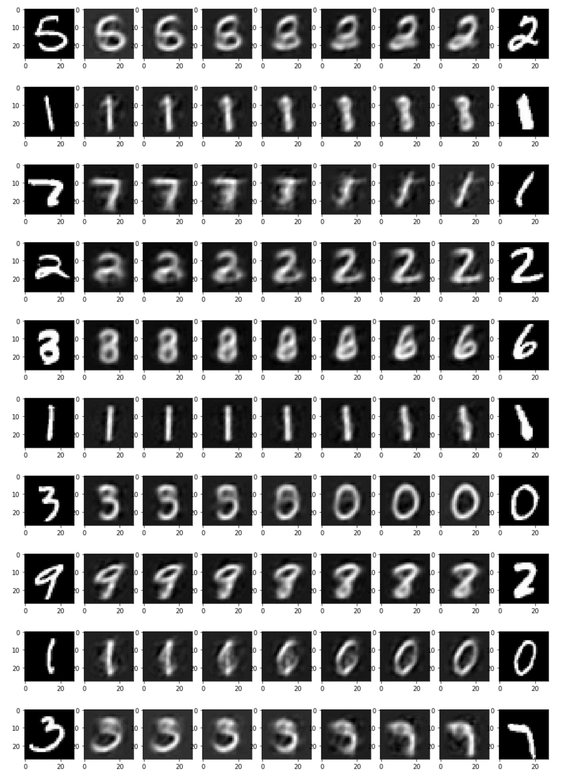

# Code

|  |
| --- |
| ****Homework 9: Variational Autoencoders********About********Due**** Monday 4/22/19, 11:59 PM CST ****Goal**** This homework focuses on creating variational autoencoders applied to the MNIST dataset. Dev EnvironmentWorking on Google Colab You may choose to work locally or on Google Colaboratory. You have access to free compute through this service.   1. Visit <https://colab.research.google.com/drive> 2. Navigate to the **Upload** tab, and upload your HW10.ipynb 3. Now on the top right corner, under the Comment and Share options, you should see a Connect option. Once you are connected, you will have access to a VM with 12GB RAM, 50 GB disk space and a single GPU. The dropdown menu will allow you to connect to a local runtime as well.   **Notes:**   * **If you do not have a working setup for Python 3, this is your best bet. It will also save you from heavy installations like tensorflow if you don't want to deal with those.** * **There is a downside. You can only use this instance for a single 12-hour stretch, after which your data will be deleted, and you would have redownload all your datasets, any libraries not already on the VM, and regenerate your logs**.  Installing PyTorch and Dependencies The instructions for installing and setting up PyTorch can be found at <https://pytorch.org/get-started/locally/>. Make sure you follow the instructions for your machine. For any of the remaining libraries used in this assignment:   * We have provided a hw8\_requirements.txt file on the homework web page. * Download this file, and in the same directory you can run pip3 install -r hw8\_requirements.txt   Check that PyTorch installed correctly by running the following:  In [1]:  **import** **torch**  torch.rand(5, 3)  Out[1]:  tensor([[0.3107, 0.3403, 0.9030],  [0.3666, 0.2765, 0.4050],  [0.9817, 0.2669, 0.7267],  [0.6591, 0.7676, 0.4878],  [0.6755, 0.2200, 0.9744]])  The output should look something like  tensor([[0.3380, 0.3845, 0.3217],  [0.8337, 0.9050, 0.2650],  [0.2979, 0.7141, 0.9069],  [0.1449, 0.1132, 0.1375],  [0.4675, 0.3947, 0.1426]]) Let's get started with the assignment.****Instructions********Part 1 - Datasets and Dataloaders**** This part of the assignment is similar to HW 8.  **Create a directory named hw9\_data with the following command.**  In [2]:  !mkdir hw9\_data  **Now use torch.datasets.MNIST to load the Train and Test data into hw9\_data.**   * **Use the directory you created above as the root directory for your datasets** * **Populate the transformations variable with any transformations you would like to perform on your data.** (Hint: You will need to do at least one) * **Pass your transformations variable to torch.datasets.MNIST. This allows you to perform arbitrary transformations to your data at loading time.**   In [3]:  **from** **torchvision** **import** datasets, transforms  *## YOUR CODE HERE ##*  transformations = transforms.Compose([transforms.ToTensor()])  mnist\_train = datasets.MNIST(root='./hw9\_data',train=**True**,download=**True**,transform=transformations)  mnist\_test = datasets.MNIST(root='./hw9\_data',train=**False**,download=**True**,transform=transformations)  0it [00:00, ?it/s]  Downloading http://yann.lecun.com/exdb/mnist/train-images-idx3-ubyte.gz to ./hw9\_data/MNIST/raw/train-images-idx3-ubyte.gz  98%|█████████▊| 9732096/9912422 [00:11<00:00, 2623780.04it/s]  Extracting ./hw9\_data/MNIST/raw/train-images-idx3-ubyte.gz  0it [00:00, ?it/s]  Downloading http://yann.lecun.com/exdb/mnist/train-labels-idx1-ubyte.gz to ./hw9\_data/MNIST/raw/train-labels-idx1-ubyte.gz  0%| | 0/28881 [00:00<?, ?it/s]  57%|█████▋ | 16384/28881 [00:00<00:00, 53968.44it/s]  32768it [00:00, 37085.20it/s]  0it [00:00, ?it/s]  Extracting ./hw9\_data/MNIST/raw/train-labels-idx1-ubyte.gz  Downloading http://yann.lecun.com/exdb/mnist/t10k-images-idx3-ubyte.gz to ./hw9\_data/MNIST/raw/t10k-images-idx3-ubyte.gz  0%| | 0/1648877 [00:00<?, ?it/s]  1%| | 16384/1648877 [00:00<00:30, 52681.17it/s]  2%|▏ | 40960/1648877 [00:01<00:25, 62743.01it/s]  6%|▌ | 98304/1648877 [00:01<00:19, 81341.85it/s]  9%|▉ | 155648/1648877 [00:01<00:14, 102891.30it/s]  13%|█▎ | 212992/1648877 [00:01<00:11, 126321.62it/s]  16%|█▋ | 270336/1648877 [00:01<00:09, 150066.30it/s]  20%|██ | 335872/1648877 [00:02<00:07, 175063.70it/s]  24%|██▍ | 401408/1648877 [00:02<00:06, 201463.07it/s]  28%|██▊ | 466944/1648877 [00:02<00:05, 225119.55it/s]  32%|███▏ | 532480/1648877 [00:02<00:04, 261786.70it/s]  37%|███▋ | 606208/1648877 [00:02<00:03, 324277.39it/s]  40%|███▉ | 655360/1648877 [00:03<00:03, 298799.55it/s]  42%|████▏ | 696320/1648877 [00:03<00:03, 263902.56it/s]  47%|████▋ | 770048/1648877 [00:03<00:02, 307857.65it/s]  52%|█████▏ | 851968/1648877 [00:03<00:02, 377266.53it/s]  55%|█████▌ | 909312/1648877 [00:03<00:02, 340015.53it/s]  58%|█████▊ | 958464/1648877 [00:03<00:02, 321866.85it/s]  64%|██████▎ | 1048576/1648877 [00:04<00:01, 370289.64it/s]  67%|██████▋ | 1097728/1648877 [00:04<00:01, 393349.78it/s]  70%|██████▉ | 1146880/1648877 [00:04<00:01, 409950.15it/s]  73%|███████▎ | 1196032/1648877 [00:04<00:01, 423171.11it/s]  76%|███████▌ | 1253376/1648877 [00:04<00:00, 451525.98it/s]  79%|███████▉ | 1302528/1648877 [00:04<00:00, 459325.64it/s]  82%|████████▏ | 1359872/1648877 [00:04<00:00, 488121.76it/s]  86%|████████▌ | 1417216/1648877 [00:04<00:00, 496073.30it/s]  90%|████████▉ | 1482752/1648877 [00:04<00:00, 527349.97it/s]  93%|█████████▎| 1540096/1648877 [00:05<00:00, 529585.06it/s]  97%|█████████▋| 1605632/1648877 [00:05<00:00, 560881.52it/s]  1654784it [00:05, 316396.19it/s]  0it [00:00, ?it/s]  Extracting ./hw9\_data/MNIST/raw/t10k-images-idx3-ubyte.gz  Downloading http://yann.lecun.com/exdb/mnist/t10k-labels-idx1-ubyte.gz to ./hw9\_data/MNIST/raw/t10k-labels-idx1-ubyte.gz  0%| | 0/4542 [00:00<?, ?it/s]  8192it [00:00, 17965.86it/s]  Extracting ./hw9\_data/MNIST/raw/t10k-labels-idx1-ubyte.gz  Processing...  Done!  **Any file in our dataset will now be read at runtime, and the specified transformations we need on it will be applied when we need it.**.  We could iterate through these directly using a loop, but this is not idiomatic. PyTorch provides us with this abstraction in the form of DataLoaders. The module of interest is torch.utils.data.DataLoader.  DataLoader allows us to do lots of useful things   * Group our data into batches * Shuffle our data * Load the data in parallel using multiprocessing workers   **Use DataLoader to create a loader for the training set and one for the testing set**   * **Use a batch\_size of 32 to start, you may change it if you wish.** * **Set the shuffle parameter to True.**   **Check that the data was loaded successfully before proceeding to the next sections.**  In [4]:  **from** **torch.utils.data** **import** DataLoader  *## YOUR CODE HERE ##*  train\_loader = DataLoader(mnist\_train, batch\_size=100, shuffle=**True**, num\_workers=1)  test\_loader = DataLoader(mnist\_test, batch\_size=100, shuffle=**True**, num\_workers=1) ****Part 2 - Encoder and Decoders (0 points)**** In this section we will be creating the encoder and decoder for our variational autoencoder (VAE).  You can take a look at the following to understand how VAE's work.   * <https://towardsdatascience.com/intuitively-understanding-variational-autoencoders-1bfe67eb5daf> * <http://kvfrans.com/variational-autoencoders-explained/> * <https://jmetzen.github.io/2015-11-27/vae.html>   VAEs work around a latent space who's dimension can be chosen by us. We will leave this as a parameter for the Encoder and Decoder classes that you will have to populate.  Feel free to use any network architecture that you wish. Try simpler network structures like a few linear layers before trying anything more complicated. For the Encoder:  * **Finish the init() function.** * **Finish the forward() function.** * **Assume that input to forward, x, is of shape (batch\_size, 28,28)** * **forward() should return two tensors of size latent\_dim like a standard encoder of a VAE** * **One of the tensors should correspond to the mean of the encoding and the other tensor should correspond to the variance. In practice, it is easier to model the output as the log of the variance (logvar) and we will too**  For the Decoder:  * **Finish the init() function.** * **Finish the forward() function.** * **Assume that input to forward, x, is of shape (batch\_size, latent\_dim)** * **forward() should return a tensor of shape (batch\_size, 28,28)** * **Make sure that the output lies in the same range as the input to the encoder (Hint: Sigmoid?)**   In [5]:  **from** **torch** **import** nn  **class** **Encoder**(nn.Module):  **def** \_\_init\_\_(self, latent\_dim):  super(Encoder, self).\_\_init\_\_()  self.encoder = nn.Sequential(  nn.Linear(784, 400),  nn.ReLU()  )  self.em = nn.Linear(400,latent\_dim) *# mu layer*  self.ev = nn.Linear(400,latent\_dim) *# logvariance layer*    **def** forward(self, x):  out = self.encoder(x)  mu = self.em(out)  logvar = self.ev(out)  **return** mu,logvar    **class** **Decoder**(nn.Module):  **def** \_\_init\_\_(self, latent\_dim):  super(Decoder, self).\_\_init\_\_()  self.decoder = nn.Sequential(  nn.Linear(latent\_dim, 400),  nn.ReLU(),  nn.Linear(400, 784)  )  **def** forward(self,x):  x\_hat = self.decoder(x)  **return** x\_hat ****Part 3: Training and loss functions**** (0 points) Recall that the encoder outputs the mean (mu) and the log of the variance (logvar). This implies that the latent vector of the input image follows a gaussian distribution with mean (mu) and standard deviation (e^[0.5\*logvar]). To decode this information, the decoder needs a sample from this distribution.  **Complete the sample function to generate these samples**  In [6]:  **def** sample(mu, logvar):  std = logvar.mul(0.5).exp\_()  eps = torch.FloatTensor(std.size()).normal\_()  eps = torch.autograd.Variable(eps)  **return** eps.mul(std).add\_(mu)  We also need to create the loss function. Assume that x are your input images and x\_hat are your reconstructions of these input images, complete the following loss for a VAE. (Hint: You will need to use mu and logvar as well)  In [7]:  **def** vae\_loss(x, x\_hat, mu, logvar):  reconstruction\_function = nn.MSELoss(size\_average=**False**)  BCE = reconstruction\_function(x\_hat, x)  KLD = mu.pow(2).add\_(logvar.exp()).mul\_(-1).add\_(1).add\_(logvar)  KLD = torch.sum(KLD).mul\_(-0.5)  **return** BCE + KLD  In the following we will instantiate an Encoder and Decoder with a latent dimension of 32.  We also define a single optimizer that optimizes the parameters of both the Encoder and the Decoder together. Feel free to use any optimizer of your choice.  In [8]:  **from** **torch** **import** optim  *## YOUR CODE HERE ##*  encoder = Encoder(20)  decoder = Decoder(20)  params = list(encoder.parameters())+list(decoder.parameters())  optimizer = optim.Adam(params, lr=1e-3)  Complete the train function that takes input encoder, decoder, train\_loader, optimizer, and number of epochs you wish to train your model for.  Training will involve:   1. **One epoch is defined as a full pass of your dataset through your model. We choose the number of epochs we wish to train our model for.** 2. **For each batch, use the encoder to generate the mu and logvar.** 3. **Sample a latent vector for each image in the batch and feed this to the decoder to generate the decoded images.** 4. **Calculate the loss function for this batch.** 5. **Now calculate the gradients for each parameter you are optimizing over. (Hint: Your loss function object can do this for you)** 6. **Update your model parameters (Hint: The optimizer comes in here)** 7. **Set the gradients in your model to zero for the next batch.**   In [9]:  **def** train(encoder, decoder, train\_loader, optimizer, num\_epochs = 10):  **for** epoch **in** range(num\_epochs):  train\_loss = 0  **for** batch\_idx, data **in** enumerate(train\_loader):  img, \_ = data *#Extract image*  img = img.view(img.size(0), -1) *#Re-Size the Image*  img = torch.autograd.Variable(img) *#Variable the Image*  optimizer.zero\_grad() *#Making Zero for all the Gradient*    mu, logvar = encoder(img)  z = sample(mu, logvar)  x\_hat=decoder(z)  loss = vae\_loss(x\_hat, img, mu, logvar)  loss.backward()  train\_loss += loss.data  optimizer.step()  **if** batch\_idx % 100 == 0:  print('Train Epoch: **{}** [**{}**/**{}** (**{:.0f}**%)]**\t**Loss: **{:.6f}**'.format(  epoch,  batch\_idx \* len(img),  len(train\_loader.dataset), 100. \* batch\_idx / len(train\_loader),  loss.data / len(img)))  print('====> Epoch: **{}** Average loss: **{:.4f}**'.format(  epoch, train\_loss / len(train\_loader.dataset)))  Finally call train with the relevant parameters.  Note : This function may take a while to complete if you're training for many epochs on a cpu. This is where it comes in handy to be running on Google Colab, or just have a GPU on hand.  In [10]:  train(encoder, decoder, train\_loader, optimizer, num\_epochs = 10)  /Users/sushanta/anaconda3/lib/python3.6/site-packages/torch/nn/\_reduction.py:49: UserWarning: size\_average and reduce args will be deprecated, please use reduction='sum' instead.  warnings.warn(warning.format(ret))  Train Epoch: 0 [0/60000 (0%)] Loss: 132.178009  Train Epoch: 0 [10000/60000 (17%)] Loss: 43.739262  Train Epoch: 0 [20000/60000 (33%)] Loss: 40.663799  Train Epoch: 0 [30000/60000 (50%)] Loss: 38.585915  Train Epoch: 0 [40000/60000 (67%)] Loss: 40.661022  Train Epoch: 0 [50000/60000 (83%)] Loss: 36.237770  ====> Epoch: 0 Average loss: 41.4419  Train Epoch: 1 [0/60000 (0%)] Loss: 36.198639  Train Epoch: 1 [10000/60000 (17%)] Loss: 35.159542  Train Epoch: 1 [20000/60000 (33%)] Loss: 36.147301  Train Epoch: 1 [30000/60000 (50%)] Loss: 35.252235  Train Epoch: 1 [40000/60000 (67%)] Loss: 33.608196  Train Epoch: 1 [50000/60000 (83%)] Loss: 35.908756  ====> Epoch: 1 Average loss: 35.0167  Train Epoch: 2 [0/60000 (0%)] Loss: 33.541672  9920512it [00:30, 2623780.04it/s]  Train Epoch: 2 [10000/60000 (17%)] Loss: 32.694824  Train Epoch: 2 [20000/60000 (33%)] Loss: 34.187637  Train Epoch: 2 [30000/60000 (50%)] Loss: 32.953907  Train Epoch: 2 [40000/60000 (67%)] Loss: 34.721653  Train Epoch: 2 [50000/60000 (83%)] Loss: 34.795624  ====> Epoch: 2 Average loss: 33.9908  Train Epoch: 3 [0/60000 (0%)] Loss: 32.882137  Train Epoch: 3 [10000/60000 (17%)] Loss: 32.848618  Train Epoch: 3 [20000/60000 (33%)] Loss: 33.019115  Train Epoch: 3 [30000/60000 (50%)] Loss: 34.161644  Train Epoch: 3 [40000/60000 (67%)] Loss: 34.738590  Train Epoch: 3 [50000/60000 (83%)] Loss: 33.969429  ====> Epoch: 3 Average loss: 33.3914  Train Epoch: 4 [0/60000 (0%)] Loss: 33.041035  Train Epoch: 4 [10000/60000 (17%)] Loss: 34.164875  Train Epoch: 4 [20000/60000 (33%)] Loss: 34.213131  Train Epoch: 4 [30000/60000 (50%)] Loss: 33.009594  Train Epoch: 4 [40000/60000 (67%)] Loss: 32.651241  Train Epoch: 4 [50000/60000 (83%)] Loss: 31.368668  ====> Epoch: 4 Average loss: 32.9518  Train Epoch: 5 [0/60000 (0%)] Loss: 33.879459  Train Epoch: 5 [10000/60000 (17%)] Loss: 32.795914  Train Epoch: 5 [20000/60000 (33%)] Loss: 31.573969  Train Epoch: 5 [30000/60000 (50%)] Loss: 32.813580  Train Epoch: 5 [40000/60000 (67%)] Loss: 32.360184  Train Epoch: 5 [50000/60000 (83%)] Loss: 33.120499  ====> Epoch: 5 Average loss: 32.6001  Train Epoch: 6 [0/60000 (0%)] Loss: 33.366531  Train Epoch: 6 [10000/60000 (17%)] Loss: 32.090954  Train Epoch: 6 [20000/60000 (33%)] Loss: 31.806473  Train Epoch: 6 [30000/60000 (50%)] Loss: 32.521469  Train Epoch: 6 [40000/60000 (67%)] Loss: 32.154099  Train Epoch: 6 [50000/60000 (83%)] Loss: 30.545992  ====> Epoch: 6 Average loss: 32.3410  Train Epoch: 7 [0/60000 (0%)] Loss: 31.471373  Train Epoch: 7 [10000/60000 (17%)] Loss: 32.185341  Train Epoch: 7 [20000/60000 (33%)] Loss: 31.739243  Train Epoch: 7 [30000/60000 (50%)] Loss: 32.678883  Train Epoch: 7 [40000/60000 (67%)] Loss: 32.802925  Train Epoch: 7 [50000/60000 (83%)] Loss: 32.281803  ====> Epoch: 7 Average loss: 32.1217  Train Epoch: 8 [0/60000 (0%)] Loss: 31.157930  Train Epoch: 8 [10000/60000 (17%)] Loss: 32.228493  Train Epoch: 8 [20000/60000 (33%)] Loss: 31.751133  Train Epoch: 8 [30000/60000 (50%)] Loss: 31.654814  Train Epoch: 8 [40000/60000 (67%)] Loss: 31.871538  Train Epoch: 8 [50000/60000 (83%)] Loss: 33.077606  ====> Epoch: 8 Average loss: 31.9796  Train Epoch: 9 [0/60000 (0%)] Loss: 31.155523  Train Epoch: 9 [10000/60000 (17%)] Loss: 32.256847  Train Epoch: 9 [20000/60000 (33%)] Loss: 31.256075  Train Epoch: 9 [30000/60000 (50%)] Loss: 32.240906  Train Epoch: 9 [40000/60000 (67%)] Loss: 31.891096  Train Epoch: 9 [50000/60000 (83%)] Loss: 32.404610  ====> Epoch: 9 Average loss: 31.8042 ****Part 4: Visualizing the VAE output**** (90 points) We will look at how well the codes produced by the VAE can be interpolated. **For this section we will only use the MNIST test set.**  To create an interpolation between two images A and B, we encode both these images and generate a sample code for each of them. We now consider 7 equally spaced points in between these two sample codes giving us a total of 9 points including the samples. We then decode these images to get interpolated images in between A and B.  Complete the interpolation function below that takes a pair of images A and B and returns 9 images. (You are free to use any data structure you want to return these images)  In [11]:  **import** **matplotlib.pyplot** **as** **plt**  **from** **torchvision** **import** utils  %**matplotlib** inline  **import** **numpy** **as** **np**  **def** create\_interpolates(A, B, encoder, decoder):  IMG\_DECODER = np.zeros((784,9))    IMG\_DECODER[:,0]=A  IMG\_DECODER[:,8]=B  mu, logvar = encoder(A)  z\_A = sample(mu, logvar)  mu, logvar = encoder(B)  z\_B = sample(mu, logvar)  Z\_I = torch.zeros((20,7))    **for** i **in** range(7):  I = z\_A + ((z\_B - z\_A)\*((i+1)/8))  Z\_I[:,i]=I    **for** i **in** range(7):  img = decoder(Z\_I[:,i])  IMG\_DECODER[:,i+1] = img.detach().numpy()    fig, ax = plt.subplots(1, 9,squeeze=**False**)  fig.set\_size\_inches(15, 2)  **for** i **in** range(1):  **for** j **in** range(9):  ax[i][j].imshow(IMG\_DECODER[:,j].reshape(28,28), cmap='gray')    **return** IMG\_DECODER  **For 10 pairs of MNIST test images of the same digit (1 pair for "0", 1 pair for "1", etc.), selected at random, compute the code for each image of the pair. Now compute 7 evenly spaced linear interpolates between these codes, and decode the result into images. Prepare a figure showing this interpolate. Lay out the figure so each interpolate is a row. On the left of the row is the first test image; then the interpolate closest to it; etc; to the last test image. You should have a 10 rows (1 row per digit) and 9 columns (7 interpolates + 2 selected test images) of images. (45 points)**  In [12]:  similar\_pairs = {}  **for** \_, (x, y) **in** enumerate(test\_loader):  **for** i **in** range(len(y)):  **if** y[i].item() **not** **in** similar\_pairs:  similar\_pairs[y[i].item()] = []  **if** len(similar\_pairs[y[i].item()])<2:  similar\_pairs[y[i].item()].append(x[i])    done = **True**  **for** i **in** range(10):  **if** i **not** **in** similar\_pairs **or** len(similar\_pairs[i])<2:  done = **False**    **if** done:  **break**  *# similar\_pairs[i] contains two images indexed at 0 and 1 that have images of the digit i*  **for** k **in** similar\_pairs.keys():  A = similar\_pairs[k][0].view(-1,)  B = similar\_pairs[k][1].view(-1,)  create\_interpolates(A, B, encoder, decoder)  /var/folders/w7/wq6tmkfx393_lw9pndw50fbc0000gn/T/com.microsoft.Word/Content.MSO/1234B947.tmp  /var/folders/w7/wq6tmkfx393_lw9pndw50fbc0000gn/T/com.microsoft.Word/Content.MSO/E00539ED.tmp  /var/folders/w7/wq6tmkfx393_lw9pndw50fbc0000gn/T/com.microsoft.Word/Content.MSO/BB35CF83.tmp  /var/folders/w7/wq6tmkfx393_lw9pndw50fbc0000gn/T/com.microsoft.Word/Content.MSO/16DA7789.tmp  /var/folders/w7/wq6tmkfx393_lw9pndw50fbc0000gn/T/com.microsoft.Word/Content.MSO/E3F8B7F.tmp  /var/folders/w7/wq6tmkfx393_lw9pndw50fbc0000gn/T/com.microsoft.Word/Content.MSO/2AF620E5.tmp  /var/folders/w7/wq6tmkfx393_lw9pndw50fbc0000gn/T/com.microsoft.Word/Content.MSO/957F693B.tmp  /var/folders/w7/wq6tmkfx393_lw9pndw50fbc0000gn/T/com.microsoft.Word/Content.MSO/CCEF1201.tmp  /var/folders/w7/wq6tmkfx393_lw9pndw50fbc0000gn/T/com.microsoft.Word/Content.MSO/3B9CA4B7.tmp  /var/folders/w7/wq6tmkfx393_lw9pndw50fbc0000gn/T/com.microsoft.Word/Content.MSO/1EBBE6DD.tmp  **For 10 pairs of MNIST test images, selected at random, compute the code for each image of the pair. Now compute 7 evenly spaced linear interpolates between these codes, and decode the result into images. Prepare a figure showing this interpolate. Lay out the figure so each interpolate is a row. On the left of the row is the first test image; then the interpolate closest to it; etc; to the last test image. You should have a 10 rows and 9 columns of images. (45 points)**  In [13]:  random\_pairs = {}  **for** \_, (x, y) **in** enumerate(test\_loader):  *# Make sure the batch size is greater than 20*  **for** i **in** range(10):  random\_pairs[i] = []  random\_pairs[i].append(x[2\*i])  random\_pairs[i].append(x[2\*i+1])  **break**  *# random\_pairs[i] contains two images indexed at 0 and 1 that are chosen at random*  **for** k **in** random\_pairs.keys():  A = random\_pairs[k][0].view(-1,)  B = random\_pairs[k][1].view(-1,)  create\_interpolates(A, B, encoder, decoder)  /var/folders/w7/wq6tmkfx393_lw9pndw50fbc0000gn/T/com.microsoft.Word/Content.MSO/2C7439F3.tmp  /var/folders/w7/wq6tmkfx393_lw9pndw50fbc0000gn/T/com.microsoft.Word/Content.MSO/9FCEFB79.tmp  /var/folders/w7/wq6tmkfx393_lw9pndw50fbc0000gn/T/com.microsoft.Word/Content.MSO/C394E4EF.tmp  /var/folders/w7/wq6tmkfx393_lw9pndw50fbc0000gn/T/com.microsoft.Word/Content.MSO/2CF26BD5.tmp  /var/folders/w7/wq6tmkfx393_lw9pndw50fbc0000gn/T/com.microsoft.Word/Content.MSO/847B21AB.tmp  /var/folders/w7/wq6tmkfx393_lw9pndw50fbc0000gn/T/com.microsoft.Word/Content.MSO/6FE413F1.tmp  /var/folders/w7/wq6tmkfx393_lw9pndw50fbc0000gn/T/com.microsoft.Word/Content.MSO/D88D2C27.tmp  /var/folders/w7/wq6tmkfx393_lw9pndw50fbc0000gn/T/com.microsoft.Word/Content.MSO/DAB18FCD.tmp  /var/folders/w7/wq6tmkfx393_lw9pndw50fbc0000gn/T/com.microsoft.Word/Content.MSO/ED70063.tmp  /var/folders/w7/wq6tmkfx393_lw9pndw50fbc0000gn/T/com.microsoft.Word/Content.MSO/AD43B69.tmp |